Ex No : 4 Code Debugging
Date :

Aim
1. Learn how to debug AngularJS applications using Chrome DevTools.
- Understand common errors like undefined variables, incorrect bindings, and controller issues.
- Identify and fix the issue where a form's input is not updating the scope variable.
- Resolve an issue where a controller is not properly binding a model to the view.
- Use Chrome DevTools to inspect the scope and watch how variables change in real-time.

2. Learn how to debug a Node.js application using Node Inspector or built-in debugging tools.
- Understand common errors such as uncaughtException, async/await issues, and route handling problems.
- Identify and resolve an issue with a route that is returning the wrong status code.
- Use breakpoints to step through code execution and understand the flow of asynchronous operations.
Code
Screen Shots
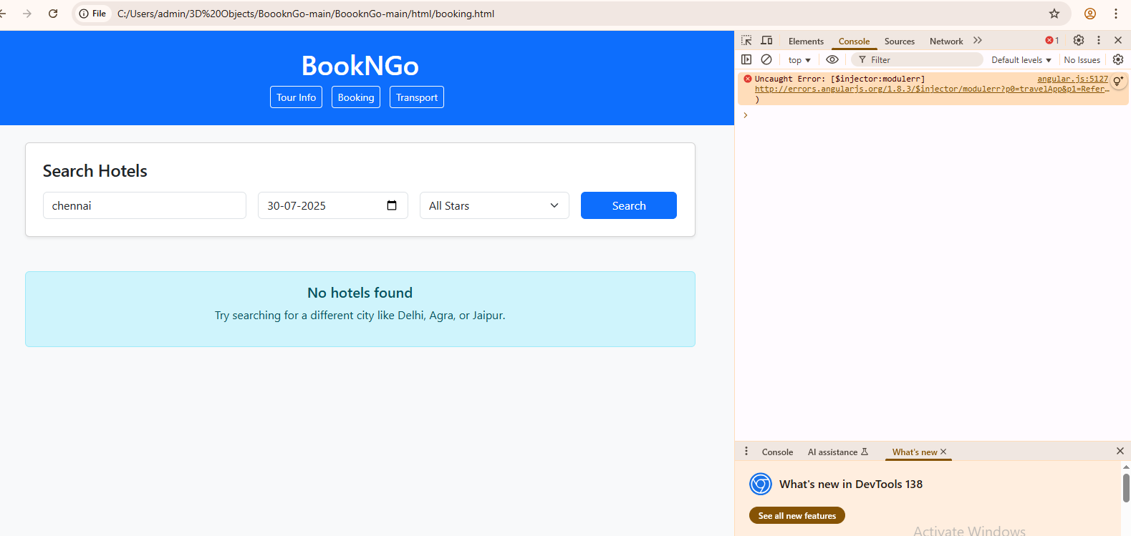
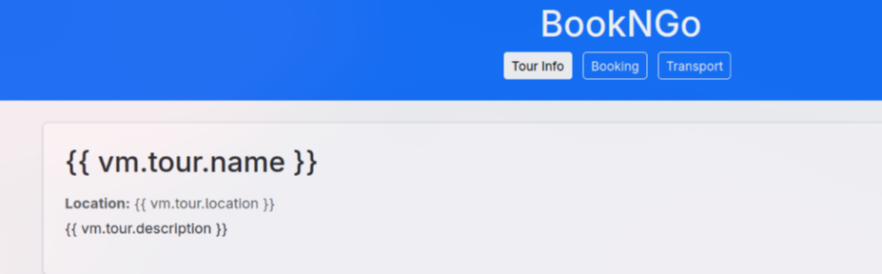
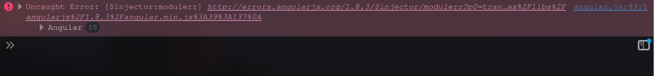
Fix : Minor spelling mistake

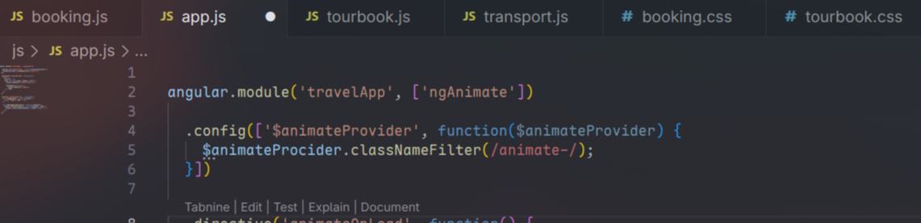
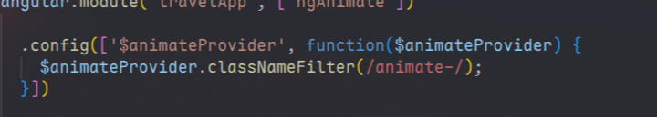
animateProcider → animateProvider.
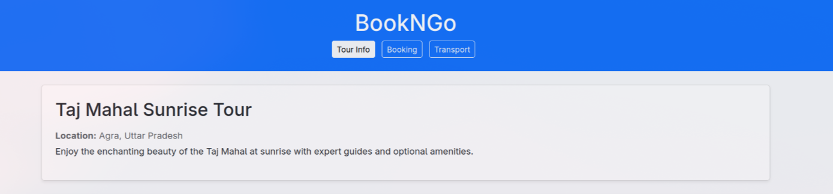
Fix Results:
ii.
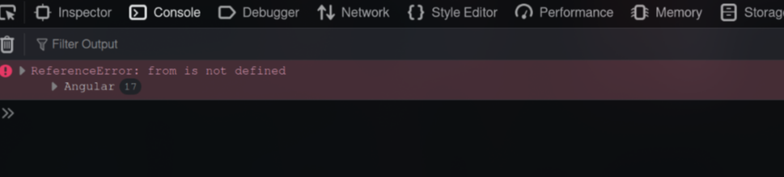
Fix
Javascript Syntax Error:
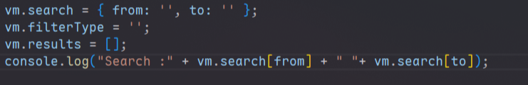
TO
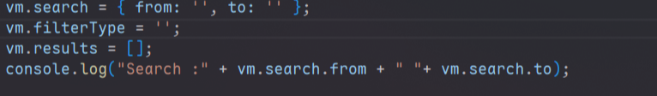
Fix results:
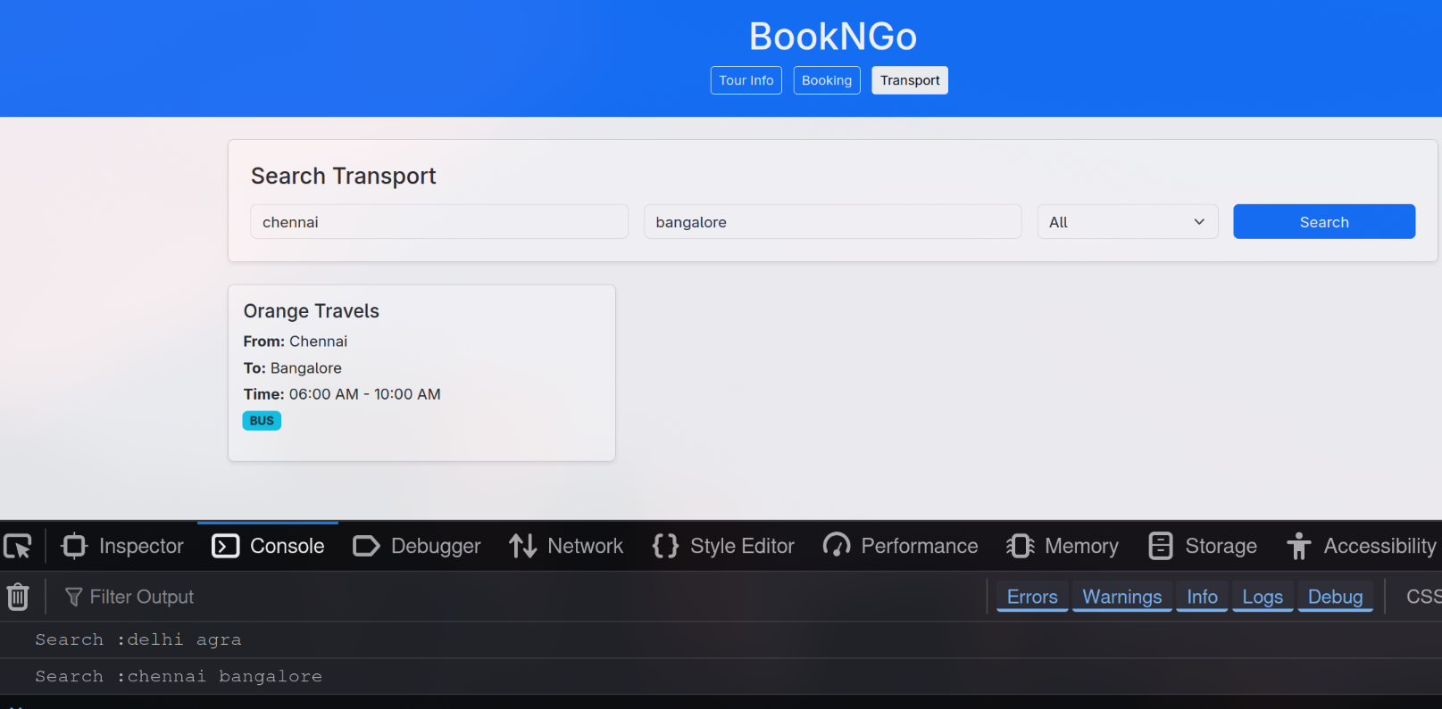
II.Node JS:
1.
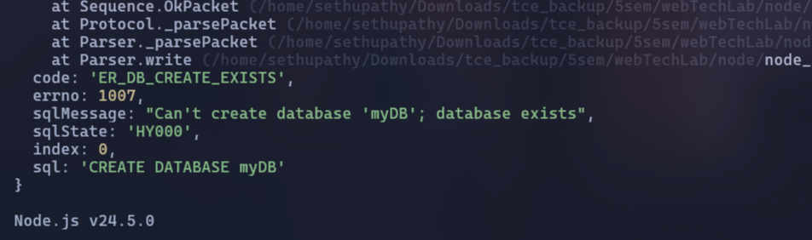
Fix :
conn.query("CREATE DATABASE IF NOT EXISTS myDB",function(err,res){
if(err){
}
console.log("myDB created");
});

2.
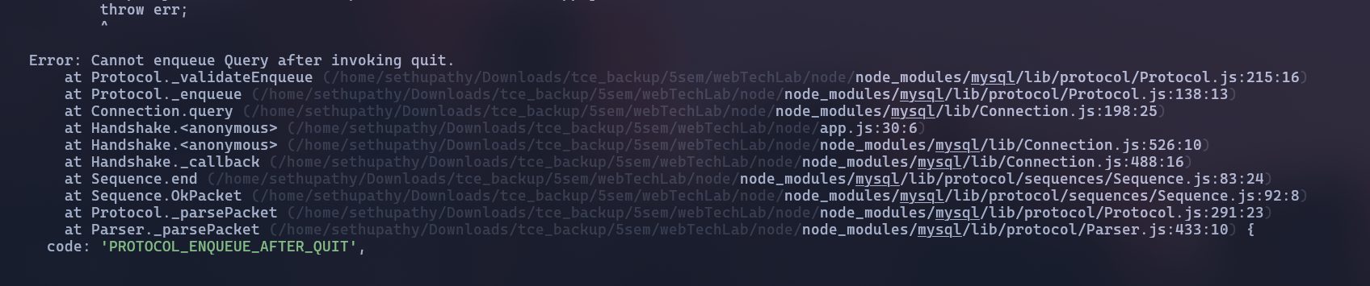
Fix :
Removing conn.end() / or use it on th EOF
3.
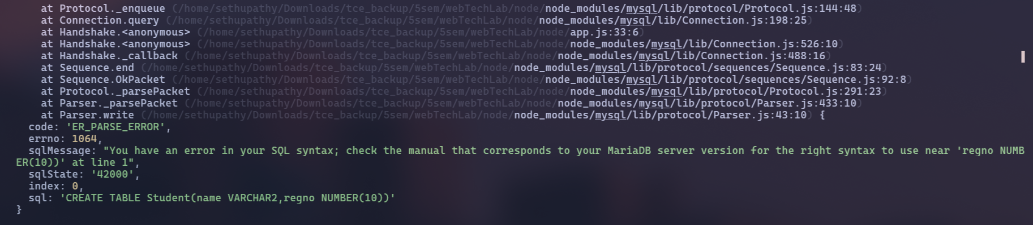
Fix:
Use INT and VARCHAR(n)
conn.query("CREATE TABLE IF NOT EXISTS Student(name VARCHAR(200),regno INT)",function(err,res){
if(err){
throw err;
}
console.log("Table created");
});
Fix output:
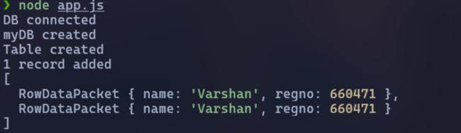
Result:
The debugging process in Chrome DevTools successfully identified and fixed AngularJS issues such as undefined variables, incorrect bindings, and scope update problems. Node.js debugging with Node Inspector resolved route status code errors and async flow issues. Breakpoints and variable inspection enabled real-time tracking of changes in both front-end and back-end. Overall, the experiment improved proficiency in locating and fixing errors in AngularJS and Node.js applications.

